Cointegration and ECM: GBPUSD and AUDUSD
Method 27 / Engle-Granger on log closes / one-lag ECM / Alpari D1 full available history

Study setup
Logical pair: PX=GBPUSD , PY=AUDUSD
Broker symbols: GBPUSD_i , AUDUSD_i
Snapshot: 2026-11-03_majors_alpari_D1
Timeframe: D1
Matched window: 1999-01-05 to 2026-11-02 (UTC bar dates)
Matched level count n: 7228
Dropped unfinished last bar dated 2026-11-03 UTC after a tick-volume check against the prior complete day.
ECM lags of deltas: 1
Complete matched rows (Excel): GBPUSD-AUDUSD_Coint_D1.xlsx
Complete matched rows (HTML table): GBPUSD-AUDUSD_Coint_D1_data.html

Method carried forward
Engle-Granger cointegration works on log price levels, not returns. For each unordered pair, PX is the left leg and PY the right leg. Step one: OLS ln(PY) = alpha + beta * ln(PX) + e. Step two: statsmodels Engle-Granger coint test on (ln(PY), ln(PX)). Error-correction: delta ln(PY)_t = c + kappa * e_{t-1} + lagged delta ln(PY) and delta ln(PX) (one lag each) + u_t. Headline is the Engle-Granger p-value (lower = stronger evidence of a stationary spread) with kappa and beta reported alongside. Same-sample Pearson r of log returns is a side check only. beta is not an automatic lot-size hedge. This is not a trading signal.

Results (headline)
alpha: -0.495926
beta: 0.479909
Engle-Granger t: -1.847773
Engle-Granger p: 0.606241
5% critical value: -3.336976
ECM kappa: -0.000947
kappa t-stat: -1.7471
ECM R^2: 0.002371
spread std: 0.163598
Pearson r (returns): 0.539048

Conclusion
Engle-Granger for PY=AUDUSD on PX=GBPUSD: beta=0.4799, alpha=-0.4959, coint_t=-1.8478, p=0.6062 (5% crit=-3.3370). ECM kappa=-0.0009 (t=-1.75). Pearson r of returns = 0.5390. beta is not a lot-size hedge. Not a trading signal.

Charts
Daily closes

Engle-Granger residual spread
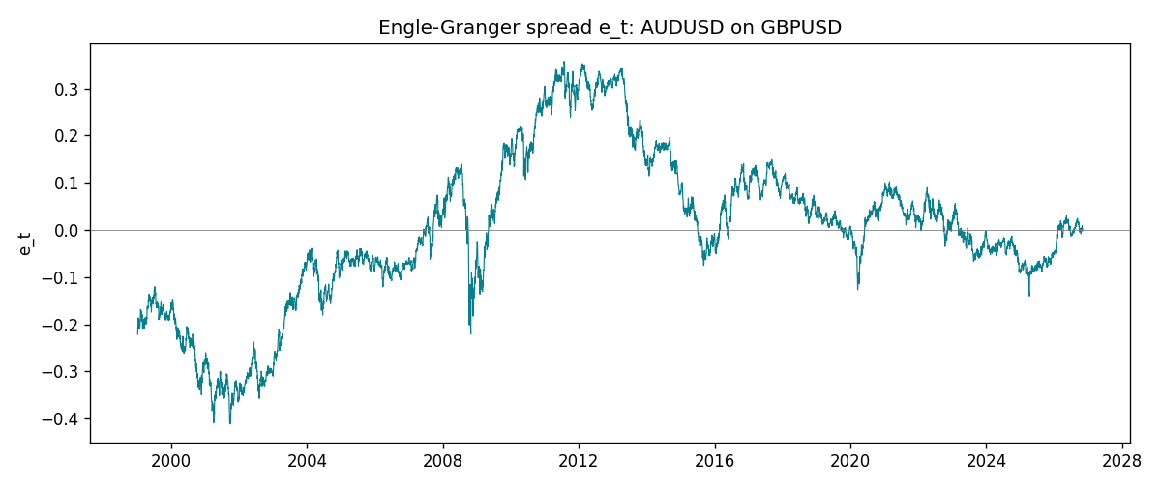
Daily log returns
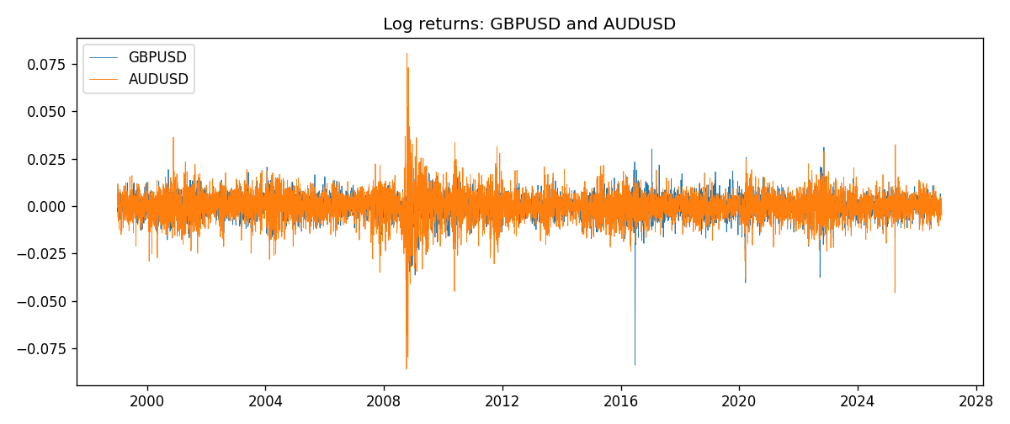

Data report
Matched rows are in the sibling Excel workbook named GBPUSD-AUDUSD_Coint_D1.xlsx. Embedding all rows as a Word table is impractical; this file holds column summaries and the first and last 15 matched rows.
Column summaries
column | count | mean | std | min | 25% | 50% | 75% | max
GBPUSD_open | 7228 | 1.5166822 | 0.21834818 | 1.06854 | 1.3254025 | 1.51196 | 1.63237 | 2.1066
AUDUSD_open | 7228 | 0.75192541 | 0.13534725 | 0.4785 | 0.66102 | 0.7315 | 0.8091975 | 1.10284
GBPUSD_high | 7228 | 1.5229801 | 0.21891417 | 1.08366 | 1.3300275 | 1.518725 | 1.638825 | 2.1161
AUDUSD_high | 7228 | 0.75597511 | 0.13590934 | 0.4878 | 0.664695 | 0.734945 | 0.81552 | 1.10795
GBPUSD_low | 7228 | 1.5103473 | 0.21757706 | 1.03518 | 1.32009 | 1.50469 | 1.624985 | 2.0983
AUDUSD_low | 7228 | 0.74786335 | 0.13465689 | 0.4775 | 0.6577 | 0.72762 | 0.804475 | 1.0975
GBPUSD_close | 7228 | 1.5167386 | 0.2183035 | 1.06879 | 1.32568 | 1.51203 | 1.6324775 | 2.1065
AUDUSD_close | 7228 | 0.75196864 | 0.13532707 | 0.4786 | 0.6611875 | 0.731775 | 0.809315 | 1.10169
GBPUSD_tick_volume | 7228 | 94565.268 | 153330.81 | 62 | 9974.5 | 52775.5 | 91622.5 | 1273370
AUDUSD_tick_volume | 7228 | 77126.179 | 137934.11 | 109 | 5406 | 43250.5 | 71246.75 | 1234623
GBPUSD_spread | 7228 | 27.003182 | 19.183813 | 0 | 11 | 20 | 50 | 50
AUDUSD_spread | 7228 | 30.855562 | 16.875394 | 0 | 13 | 30 | 50 | 50
GBPUSD_real_volume | 7228 | 3.5428062e+09 | 8.4280615e+10 | 0 | 0 | 0 | 0 | 2.4038164e+12
AUDUSD_real_volume | 7228 | 5.2225089e+09 | 1.2514647e+11 | 0 | 0 | 0 | 0 | 3.811512e+12
GBPUSD_log_price | 7228 | 0.40651132 | 0.14088711 | 0.06652717 | 0.28192553 | 0.41345312 | 0.4900988 | 0.7450278
AUDUSD_log_price | 7228 | -0.30083709 | 0.1770191 | -0.7368901 | -0.41371782 | -0.31228219 | -0.21156707 | 0.09684536
GBPUSD_log_return | 7228 | -2.954e-05 | 0.0056473 | -0.08388241 | -0.00313242 | 3.002e-05 | 0.00317333 | 0.03112653
AUDUSD_log_return | 7228 | 1.629e-05 | 0.00754363 | -0.08602525 | -0.00386494 | 0.00027649 | 0.00415111 | 0.0806166
spread_e | 7228 | 0 | 0.16359781 | -0.41132924 | -0.08054382 | 0.0027673 | 0.0898188 | 0.35747916
ecm_fitted | 7227 | 1.64e-05 | 0.00036737 | -0.00319846 | -0.00020381 | 7.75e-06 | 0.00022664 | 0.00360033
First 15 matched rows (selected columns)
time | GBPUSD_log_price | AUDUSD_log_price | spread_e | GBPUSD_log_return | AUDUSD_log_return
1999-01-05 | 0.50361972 | -0.47561937 | -0.22138547 | -0.0028966287 | -0.00080418179
1999-01-06 | 0.5030152 | -0.46378302 | -0.209259 | -0.00060452184 | 0.011836351
1999-01-07 | 0.50089649 | -0.45491799 | -0.19937719 | -0.002118709 | 0.0088650256
1999-01-08 | 0.49500107 | -0.45460283 | -0.19623277 | -0.0058954193 | 0.00031515916
1999-01-11 | 0.48931594 | -0.44738145 | -0.18628304 | -0.0056851331 | 0.0072213815
1999-01-12 | 0.49158164 | -0.4522423 | -0.19223122 | 0.0022657001 | -0.0048608485
1999-01-13 | 0.50071468 | -0.46013251 | -0.20450445 | 0.0091330396 | -0.0078902098
1999-01-14 | 0.50265231 | -0.46282943 | -0.20813126 | 0.0019376331 | -0.002696916
1999-01-15 | 0.50089649 | -0.45570632 | -0.20016552 | -0.0017558204 | 0.007123101
1999-01-18 | 0.50210773 | -0.4547604 | -0.19980088 | 0.0012112405 | 0.00094592471
1999-01-19 | 0.50398226 | -0.44753788 | -0.19347797 | 0.0018745281 | 0.0072225153
1999-01-20 | 0.49907688 | -0.4462871 | -0.18987305 | -0.0049053846 | 0.0012507819
1999-01-21 | 0.50222878 | -0.44550616 | -0.19060473 | 0.0031518998 | 0.00078094498
1999-01-22 | 0.50470694 | -0.4577589 | -0.20404677 | 0.0024781662 | -0.012252745
1999-01-25 | 0.50591358 | -0.46171805 | -0.20858499 | 0.0012066366 | -0.0039591468
Last 15 matched rows (selected columns)
time | GBPUSD_log_price | AUDUSD_log_price | spread_e | GBPUSD_log_return | AUDUSD_log_return
2026-10-13 | 0.28166903 | -0.35923536 | 0.0015146641 | 0.0036434319 | 0.0035007712
2026-10-14 | 0.27675256 | -0.36075468 | 0.0023547996 | -0.0049164679 | -0.0015193215
2026-10-15 | 0.2833502 | -0.36829939 | -0.0083561738 | 0.0065976411 | -0.0075447063
2026-10-16 | 0.28710941 | -0.36490875 | -0.0067696092 | 0.0037592051 | 0.0033906408
2026-10-19 | 0.28535938 | -0.35982275 | -0.00084375481 | -0.0017500314 | 0.0050859986
2026-10-20 | 0.29095172 | -0.35636071 | -6.5528306e-05 | 0.0055923442 | 0.0034620426
2026-10-21 | 0.29219935 | -0.35275407 | 0.0029423599 | 0.0012476328 | 0.0036066384
2026-10-22 | 0.29242331 | -0.35402133 | 0.0015676233 | 0.00022396082 | -0.0012672558
2026-10-23 | 0.29030862 | -0.35164476 | 0.0049590499 | -0.0021146949 | 0.0023765656
2026-10-26 | 0.28787455 | -0.35484804 | 0.0029238972 | -0.0024340661 | -0.0032032829
2026-10-27 | 0.28550971 | -0.35318105 | 0.0057257924 | -0.0023648393 | 0.0016669876
2026-10-28 | 0.2870869 | -0.3490895 | 0.0090604433 | 0.0015771808 | 0.0040915541
2026-10-29 | 0.29067509 | -0.35318105 | 0.003246883 | 0.0035881935 | -0.0040915541
2026-10-30 | 0.29202015 | -0.35217082 | 0.003611614 | 0.0013450605 | 0.0010102376
2026-11-02 | 0.29311727 | -0.35708932 | -0.0018334048 | 0.0010971256 | -0.0049184984

